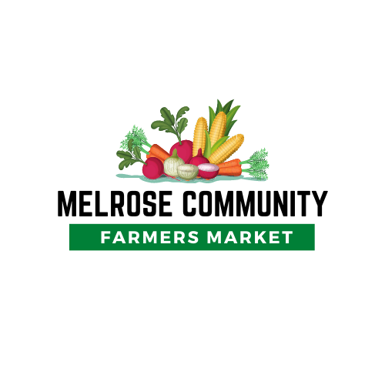

2024 Registration Form & Code of Conduct
The Melrose Community Farmers Market will strive to provide the best opportunities for local growers, makers, and sellers while promoting wellness to the community. The Melrose Farmers Market is held weekly on Wednesdays from 3-6pm from June 5th to October 2nd, 2024. The market will be held at the Sauk River Park. Please note this is a change in location from previous years. Each vendor gets approximately 10x10 space. Spaces are taken on a first-come first-serve basis each week. Food trucks will be set up in a separate area than all other vendors. You are welcome to start setting up as early as 1pm, but as a courtesy to other vendors, please do not sell any products until 3pm. Our market is set up to sell locally grown produce, foods, plants, handmade crafts, art, etc. No flea-market or direct sales products allowed unless pre-approved by the Farmers Market Committee. Please see the attached information about the POP Program for kids if you sell fruits or vegetables. The cost is $15/week or $35/season for produce only and $45/season for all other vendors. Pricing for food trucks is $100/season or $50/weekly. If your business requires a license or certificate, a copy of it will be required prior to your first day selling.

Name of Seller:_________________________________________________________________
Doing Business As: ______________________________________________________________

Mailing Address: ________________________________________________________________
Phone Number: ___________________________ Email: ________________________________
What do you plan to sell at the Melrose Community Farmers Market?
________________________________________________________________________________________________________________________________________________________________________________________________________________________________________________________________________________________________________________________

Does your product/good/service require a special license to sell to the public? ____ yes ____ no

Melrose Community Farmers Market Copyright 2024
As a seller at the Melrose Community Farmers Market, I agree to the following regulations and codes of conduct:
- Cost is $15/week or $35/season for produce-only vendors and $45/season for all other vendors. Season payment must be submitted with a form. If you choose weekly, please indicate so on your registration form. Payment must be received prior to setting up your booth.
- Food truck cost is $100/season or $50/week. Season payment must be submitted with a form. If you choose weekly, please indicate so on your registration form. Payment must be received prior to setting up your booth.
- One business per season pass or weekly pass
- All vendors must have a vendor registration form that is filled out and signed and paid for prior to 3pm on the day they are set up. Vendors with unsigned registration forms may be asked to leave.
- All vendors must keep space, tables, personal appearance, and all products clean and presentable
- Discourtesy to patrons and vendors, obscene language, and “hawking” of goods not allowed
- No smoking or alcoholic beverages allowed at the market
- All produce sold must be only locally grown
- Vendors selling processed products have the responsibility to be in compliance with MN State laws and Stearns County Health Department regulations and must submit all permits and licenses to the Melrose Farmers Market committee
- Vendors shall replace or refund to any patron who is dissatisfied with goods
- Patron complaints should be reported or directed to the Farmer's Market chair.
- Vendor complaints need to be submitted in writing to the Farmer’s Market chair.
- The Farmer’s Market chair and advisory team has final approval of all vendors.
- Vendors will allow photos to be taken and published
- Vendors are responsible for selling PoP program approved items only in exchange for PoP program token. Please ask Farmer’s Market chair or host if you are unsure which items are approved
- Pay-per-week $15 vendor payments do not go towards a season pass.
- Pay-per-week $50 food truck payments do not go towards a season pass.
The Power of Produce (PoP) Club is a farmers markets incentive program for children. It is offered at the market here in Melrose. Each week, children ages 4 to 12 receive a $2 token to spend on fresh fruits and vegetables. PoP Club engages children at farmers markets and empowers them to make healthy food choices. It aims to increase family participation at farmers markets, increase vendor revenue and build healthier communities. If you accept a token for fruits or vegetables, you can turn these into the host for a refund. All PoP tokens must be turned into host or Farmer’s Market Chair by the last day of the season (October 2, 2024.) **Tokens from previous seasons will NOT be accepted.**
I agree to the Code of Conduct above:
Signature:_____________________________ Printed Name:__________________________________
Date: ________________________________

Melrose Community Farmers Market Copyright 2024

*VENDOR SPOTLIGHT*
Please answer the questions below regarding yourself and/or your business. As a committee we would like to spotlight our vendors on our Facebook page throughout the season. These questions will help provide information about yourself/business for your spotlight. Please include 4-5 pictures of yourself and your business. Pictures can be emailed to jennarae.seawell@gmail.com.

● Tell us a little about yourself. (Where you’re from, your family, etc) ______________________________________________________________________ ______________________________________________________________________ ______________________________________________________________________ ______________________________________________________________________ ______________________________________________________________________

● When and where did your business originate from? ______________________________________________________________________ ______________________________________________________________________ ______________________________________________________________________ ______________________________________________________________________

● How long have you been in practice or doing your business? ______________________________________________________________________ ______________________________________________________________________

● Is this your full time job? ______________________________________________________________________ ______________________________________________________________________

● How long have you been a vendor for our Melrose Community Farmers Market? ______________________________________________________________________

Melrose Community Farmers Market Copyright 2024
● What items do you sell? What are your favorite items that you make/grow? ______________________________________________________________________
______________________________________________________________________ ______________________________________________________________________

● What is your favorite thing about the Melrose Community Farmers Market? ______________________________________________________________________ ______________________________________________________________________ ______________________________________________________________________ ______________________________________________________________________

● What are your hobbies or interests outside of your business? ______________________________________________________________________ ______________________________________________________________________ ______________________________________________________________________ ______________________________________________________________________

● Any other information you would like to share with us regarding yourself or your business? ______________________________________________________________________ ______________________________________________________________________ ______________________________________________________________________ ______________________________________________________________________

Please make a copy for yourself and send the original signed form along with a copy of any required license/permits and payment to:
Jennarae Barten % Melrose Community Farmer’s Market 16 6th St NE Melrose, MN 56352

Melrose Community Farmers Market Copyright 2024

